Food and Calorimetry
(lesson plan modified from http://www.sciencebuddies.org/science-fair-projects/project_ideas/FoodSci_p012.shtml#summary)

Materials:
Water
Thermometers
Safety Goggles
Balance/Scale
Food Items of Students’ Choosing (from list)
Lighter/Matches
Graduated Cylinder
Prepared Calorimeters (explained below)

Teacher Notes: Students should be split up into their project groups of 2-3. We recommend teachers prepare the calorimeters before the investigation. You will need: a cork, needle/wire (not insulated), pencil (or some other rod-like material), one small tin can, one large tin can, nail, and hammer. The set-up looks like this:

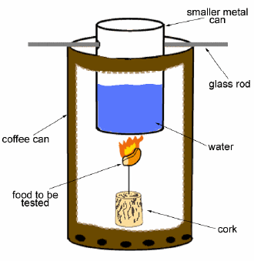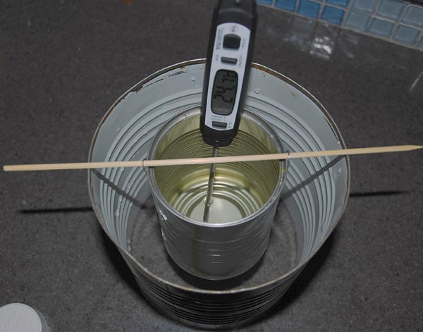
http://www.sciencebuddies.org/science-fair-projects/project_ideas/FoodSci_p012.shtml#procedure

The small can must sit high enough so the food and cork will sit below it. Remove the top and bottom of the large tin can so it’s open on both sides. Punch holes throughout the bottom of the large can so air can pass through it so the fire will stay lit using the hammer and nail. Punch two holes on opposite sides of the small can that are large enough for the support to pass through. The support must be longer than the large can’s diameter so it will stay situated. Poke the needle/wire through the cork. The sharp end of the needle is where the food to be burned will be placed, or you can wrap the wire around the food. When the students fill the can up with water, it should be about half-full.

Safety Considerations: The cans will be hot after the food has burned. Do not place the calorimeter on a flammable surface. Safety goggles should be worn at all times.

Engage:
Let students know that we will be continuing on our investigation of designing an energy bar. Give students the list of ingredients to choose from and have them discuss as a group which ingredients they’d like to test today. Let them know that they will be able to test other ingredients for the next day of this investigation if they decide to change their minds about their initial choices.

Explore:
Have students read through the handout and design their methods for data collection and analysis. This should be fairly open-ended, as students should be free to make mistakes, learn from them, and go back to try the experiment again. Question them about their data collection methods/analysis. Should we only be taking one set of data? How are you going to collect your data? How are you going to represent your data? How can we get the most accurate result from the burning of our ingredients?

Explain:
After the students have collected their data, remind them about the equation Q=mCΔT. In their notebooks with their groups, have them calculate how many Calories are in ___ grams of their ingredients. Teachers may want to refer back to the “benchmark_powerpoint_1”. Have students talk with their groups about the meaning of “efficient food source”. What about the initial and final mass of the food? If one ingredient used less mass in the burning, is it less or more efficient than the ingredient that used more? How can this be expressed mathematically? Does this play into your decision about what ingredients to use?

Elaborate:
Ask students if we only care about Calories in our foods. What else should we consider when designing our energy bar (proteins, fats, carbohydrates, etc.)? Ask students to begin researching their ingredients using the FDA website provided, the Nutrition Data website provided, or any other reliable source. Have a short conversation with students about reliable sources.

Evaluate:
Before students leave on the second day of this investigation, make sure they have completely their “Exit Ticket” addressing the rubric.

