Name___________________

Energy(Candy) Bar Wrappers
Calculating Surface Area & Volume

YOUR TASK: This activity will help prepare you for creating your own wrapper design in your final artifact. In your mathematics classes, you have been introduced to the concepts of surface area and volume, as well as the formulas needed to calculate them.
You will be provided with a variety of different energy (candy) bars to chose from. Your task is to calculate the surface area, volume, and SA/V ratio by taking measurements of 3 different bars. Please note that your calculations will reflect estimations of the actual quantities. Your goal is to decide which wrapper is most efficient in terms of the cost, production, and consumer. Use mathematical & scientific reasoning to back up your answer.

Materials
- 3 energy (candy) bars of your choice
- ruler
- measuring tape
- string

Formulas
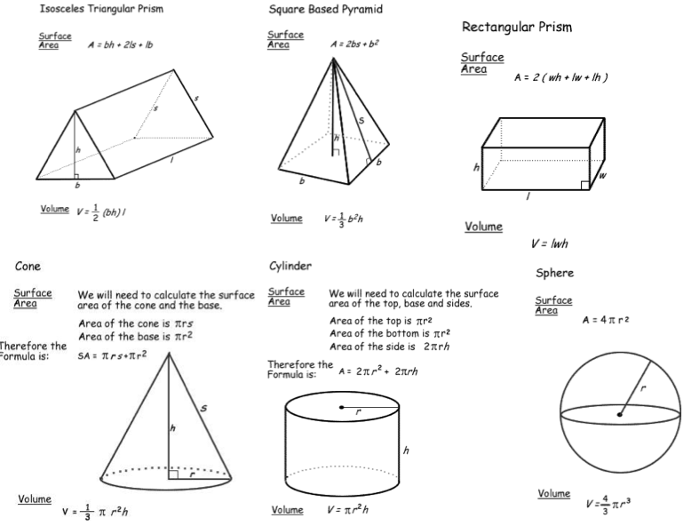

- Bar Number & Description:

Volume Calculations:

Surface Area Calculations:

- Bar Number & Description:

Volume Calculations:

Surface Area Calculations:

- Bar Number & Description:

Volume Calculations:

Surface Area Calculations:

- Using mathematical reasoning, explain which wrapper design you think is “best” in terms of cost, production, and consumer. Which wrapper design is the “worst”? Additionally, explain the mathematical approaches you took to come to this conclusion.

